- SCOPE OF WORK
The single page journey aims to simplify the entire event booking and seat selection process, providing users with a cohesive and efficient experience without the need to navigate through multiple pages.
Single Page Journey will have two distinct flows, user can switch on each experience by pressing on the specific button into the "flow mode" panel
- Choose my Seats (Ref. Deliverable #001)
- Find my Seats (Ref. Deliverable #002)
On both scenarios, we will have the additional modules added to address the required functionalities
- Flow mode panel (used to switch between Choose my Seats & Find my Seats flow type) (Ref. Deliverable #003)
- Filters Module (Ref. Deliverable #004)
- Zones grouping by prices (Ref. Deliverable #005)
- New 2d Map plugin (Ref. Deliverable #006)

DELIVERABLE #1 – CHOOSE MY SEATS
Once users reach podium page, on Flow mode panel Ref. Deliverable #003 panel, option "Choose my Seats" is selected by default.
Only the arena map will be shown, and additionally filters (Ref. Deliverable #004 / Ref. Deliverable #005) to make easier for the user to navigate between available sectors
BUSINESS CASE
Streamlined Seat Selection
Simplify the seat selection process by reducing the number of steps required to select seats.
Provide users with an intuitive interface for selecting seats, including easy navigation and selection options.
USE CASE
- When the user lands into the podium page, only the Map is shown (Refer Screenshot 1)
- No details regarding areas and products are listed next to the map, unlike what happens now.
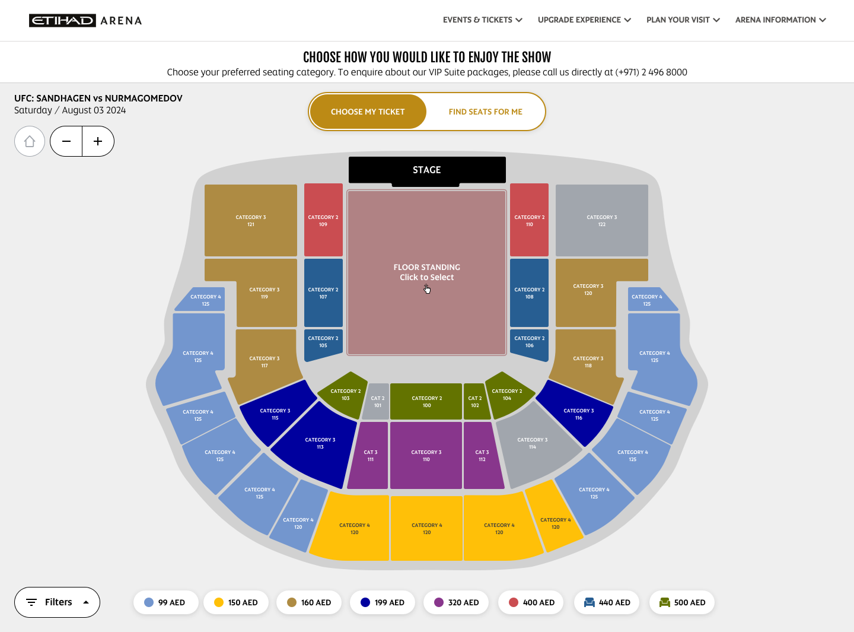
Screenshot 1 (Web View)

- We still must show texts details such as
  - Performance details (Name and date)
  - Introductory text (e.g. CHOOSE HOW YOU WOULD LIKE TO ENJOY THE SHOW - Simply hover over the different sections ...)
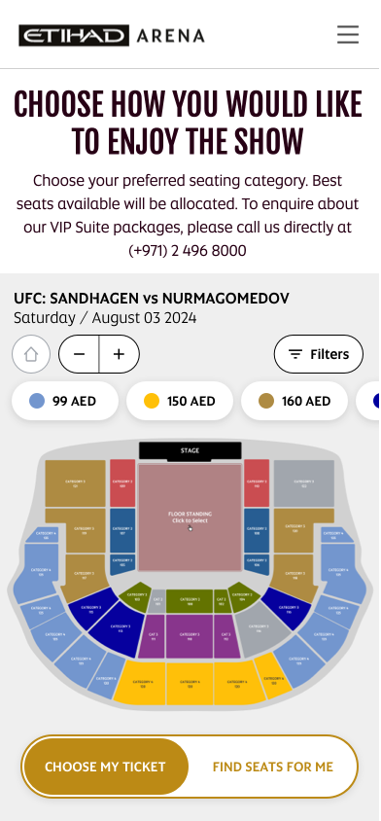
Screenshot 2 (Mobile View)
Zooming Functionality

Zooming in or clicking on a specific section, the system will show the section seats list, to allow the user to select specific seats for the selected area.

  - The zoom functionality works with:
    - Plus, Minus buttons
    - Mouse wheel for desktop visualization
    - Pinch to Zoom gesture on mobile devices
  - The seat selection map view will display
    - Available seats - the color of available seats is returned by BOS services, and can be different by each seat category available for the specific zone (space structure)
    - Each seat, could show special icons such as:
      - POD icons
      - Reduced visibility icon
  - User selects the seat/s required, and the product gets added to the cart automatically
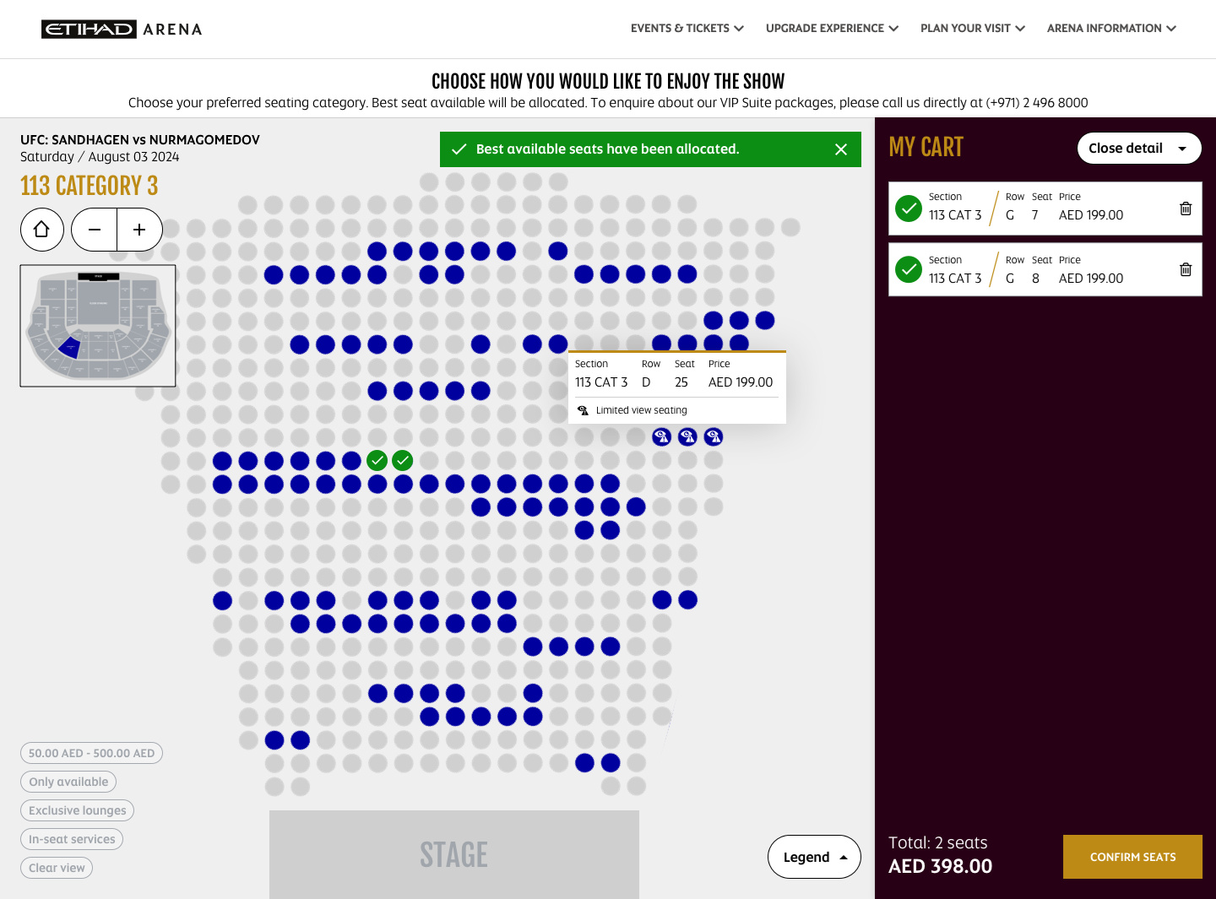
Screenshot 3 (Phase 1 – Web View)
NOTE: Phase 1 will be displayed only the seats of the specifically selected zone, not adjacent zones seats or details will be displayed.
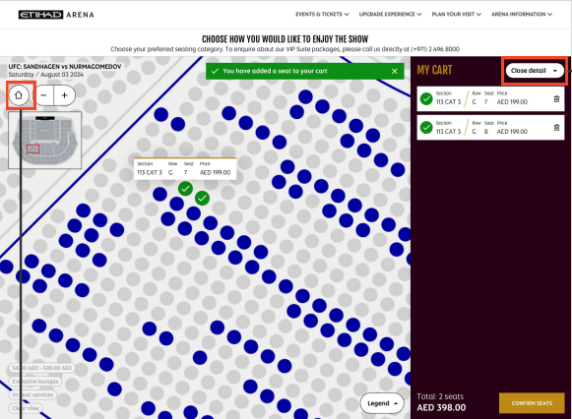
Screenshot 4 (Phase 2 - Web View)
NOTE: Phase 2 (Refer Screenshot 4) all seats of the event will be displayed.
Seat Quantity Modification
- Allow users to easily modify the quantity of seats they wish to purchase directly from the seat selection screen. The user can add or remove seats based on zone and seat Categories availabilities
- Provide users with controls to increase or decrease the number of seats and update the total price dynamically. (By unselecting the Seats)

Cart module
- If no items are into the cart, the cart is hidden
- if user has items into the cart, the cart is shown, in minimized view
- clicking the "Show details" button, the user will open the cart with details


Screenshot 5
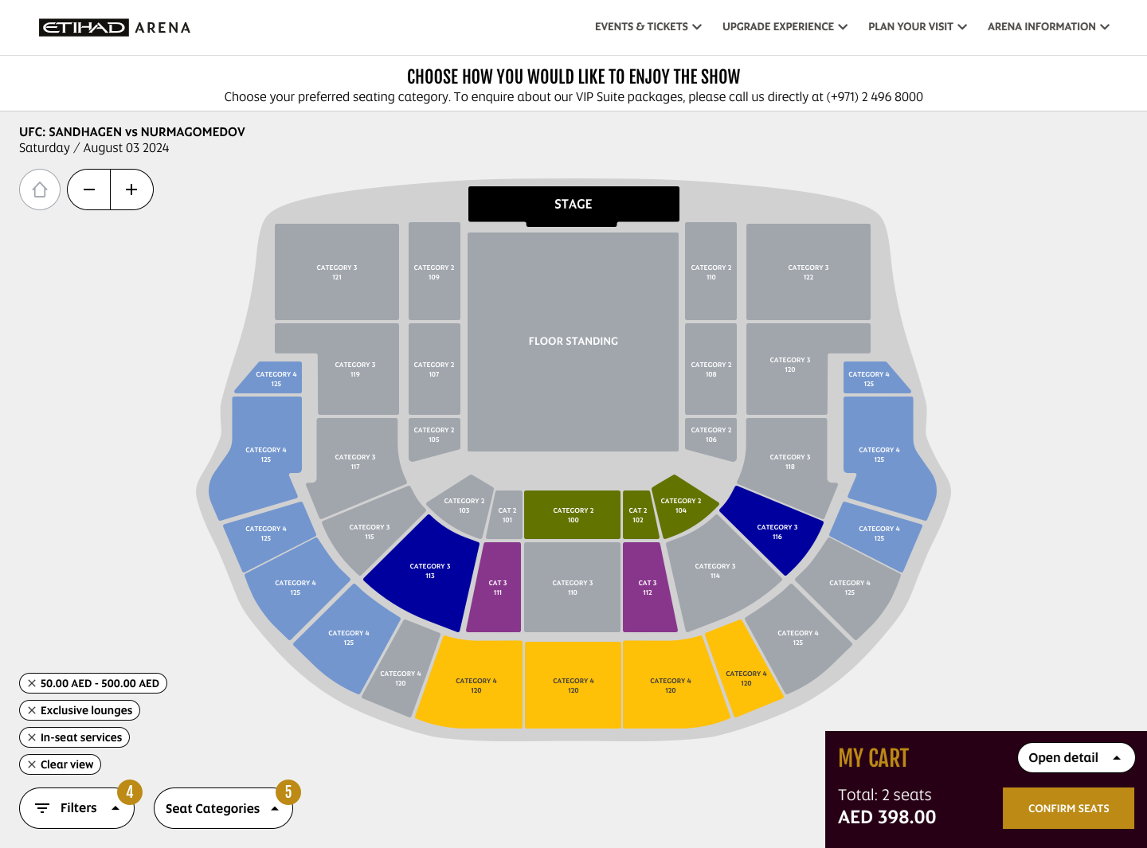
Screenshot 6
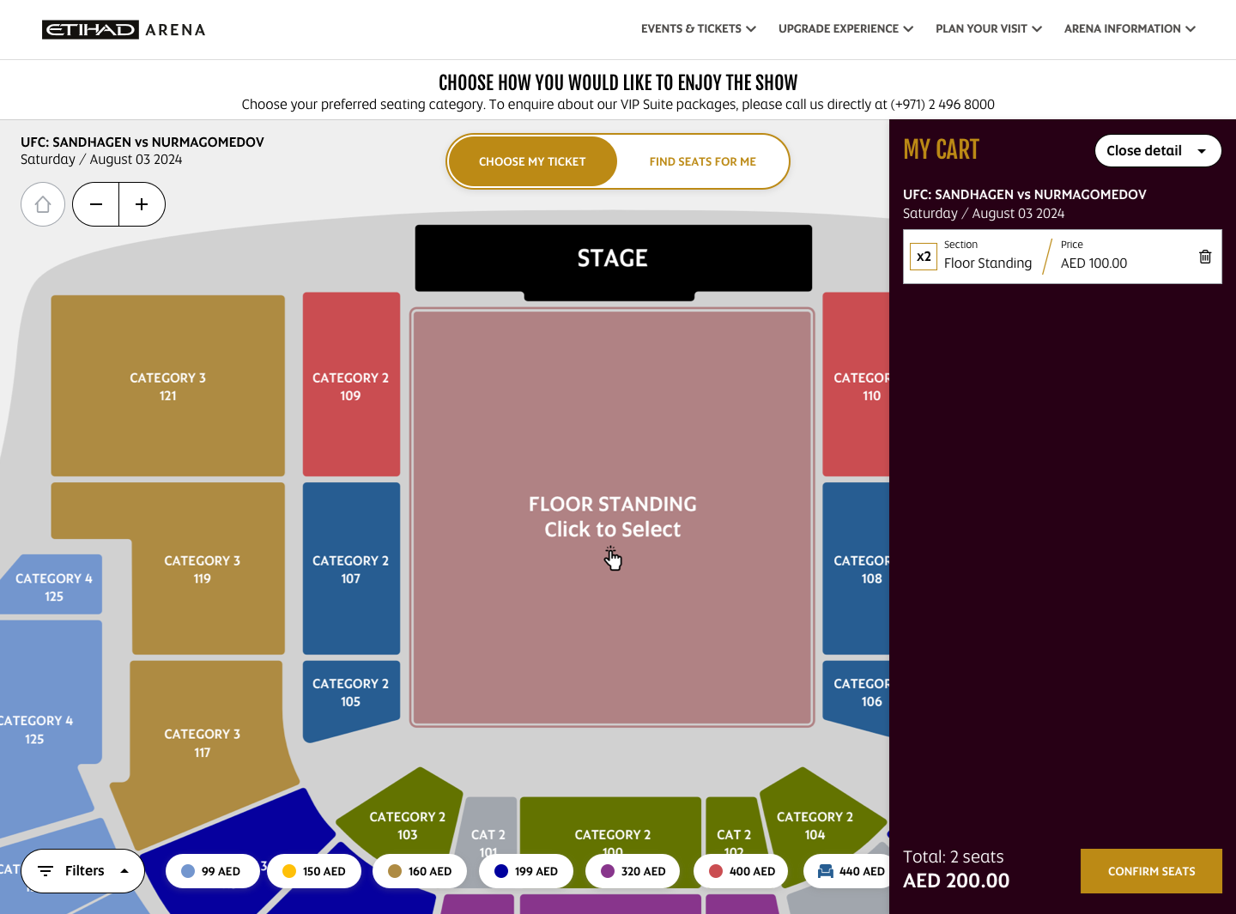
Screenshot 7
Detailed information will be shown to the user:
- Zone name
- Details about selected seats - with the possibility to remove each of them (CTA button to remove a seat)
- Quantity of tickets / seats selected – must change each time user selects / deselects seats on map
- Total amount
- A button to finalize the order
- A button to open or collapse

NON-SEATED SECTORS

Is possible to have sectors that do not require seat selection.
in that case, clicking on the sector, a popup will be shown, to add the quantity of tickets to buy (Refer Screenshot 8 & Screenshot 9)

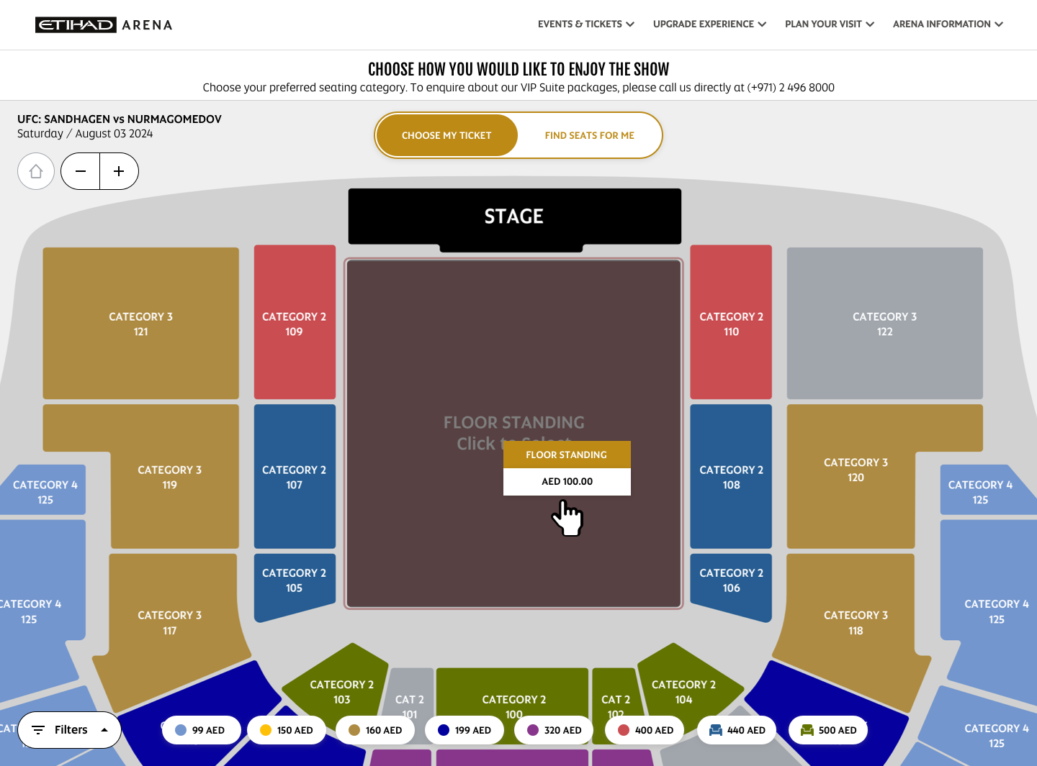
Screenshot 8
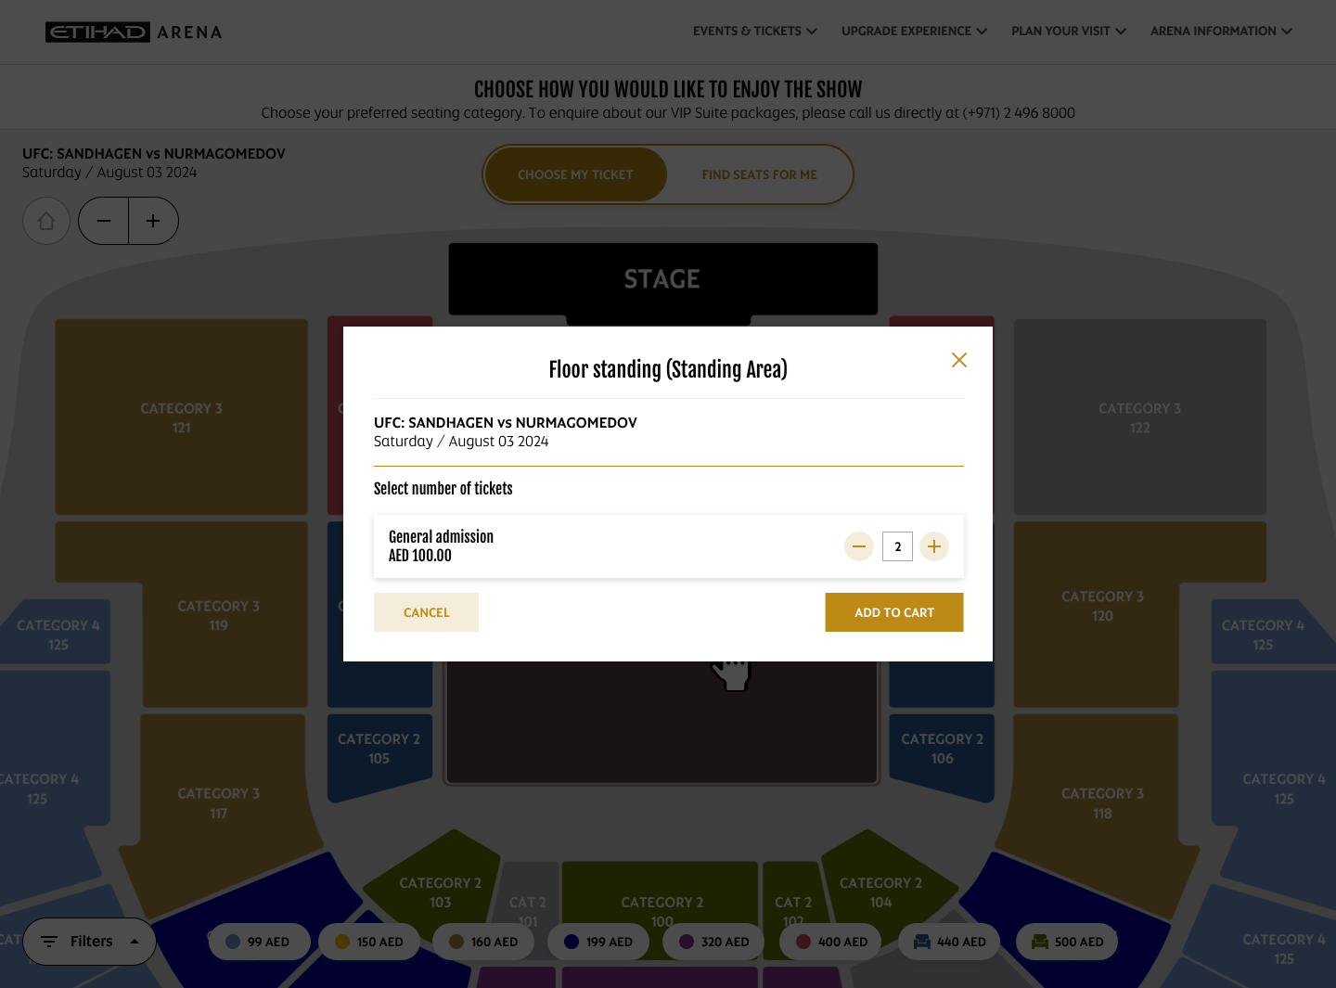
Screenshot 9
DELIVERABLE #2 – FIND MY SEATS
Once users reach podium page, on Flow mode panel Ref. Deliverable #003 panel, option "Choose my Seats" is selected by default.
When user presses the "Find seats for me" Button, the arena map will still show, the podium (List of zones grouped by category) on its page will appear, and additionally filters (Ref. Deliverable #004 / Ref. Deliverable #005) to make easier for the user to navigate between available sectors
USE CASE - FIND SEATS FOR ME
- By selecting Find Seats for Me tab the podium will show
  - DESKTOP VIEW
    - on the left, the Arena map
    - on the right the list of zones
  - MOBILE VIEW
    - on the top the Arena map (50% of the page height)
    - on the bottom the list of zones 50% of the page height)

- When user clicks on a zone into the map, the corresponding zone will be selected from the list on the right (Desktop)
  - the list of zones will focus on the selected zone (Refer Screenshot 10)
  - in the card for the selected zone, will be present a keyboard tool to input the desired quantity of tickets (Refer Screenshot 11)
  - once the quantity of tickets has been added the user can continue the purchase (Refer Screenshot 12)
NOTE: for each zone, the recommendation is to NOT show any kind of image representing the related sector on the map.
This because zones can change for each performance, and this means that an image must be created and associated to a specific zone on BOS configuration side

- By continuing the purchase, no seat map will be shown, as the system will automatically assign seats based on the quantity of tickets previously
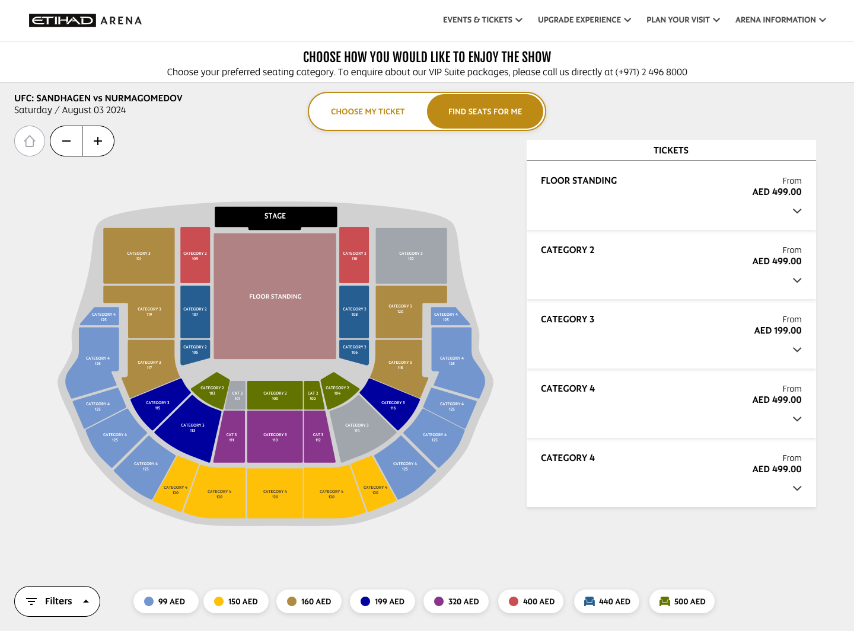
Screenshot 10
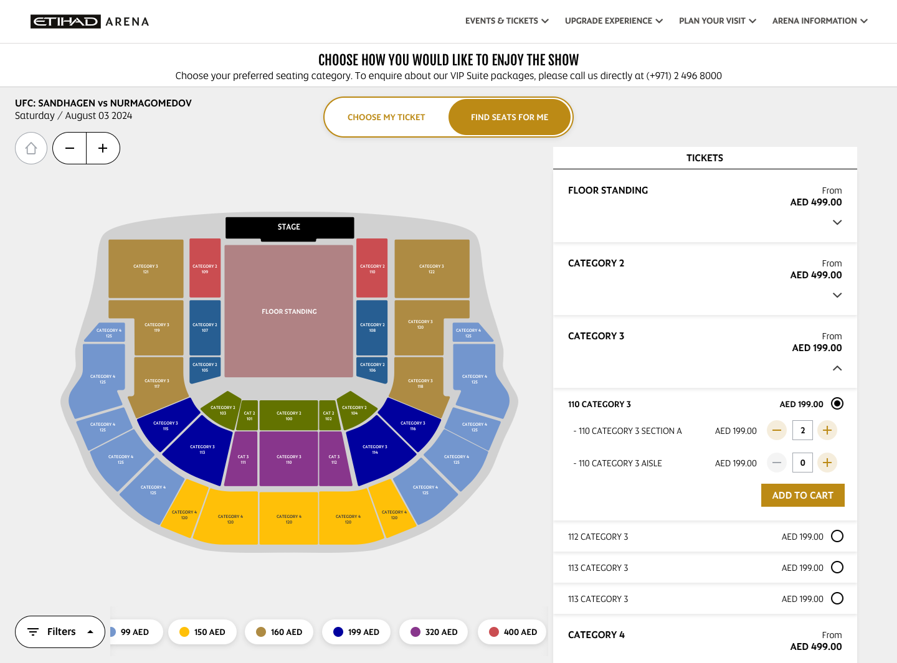
Screenshot 11

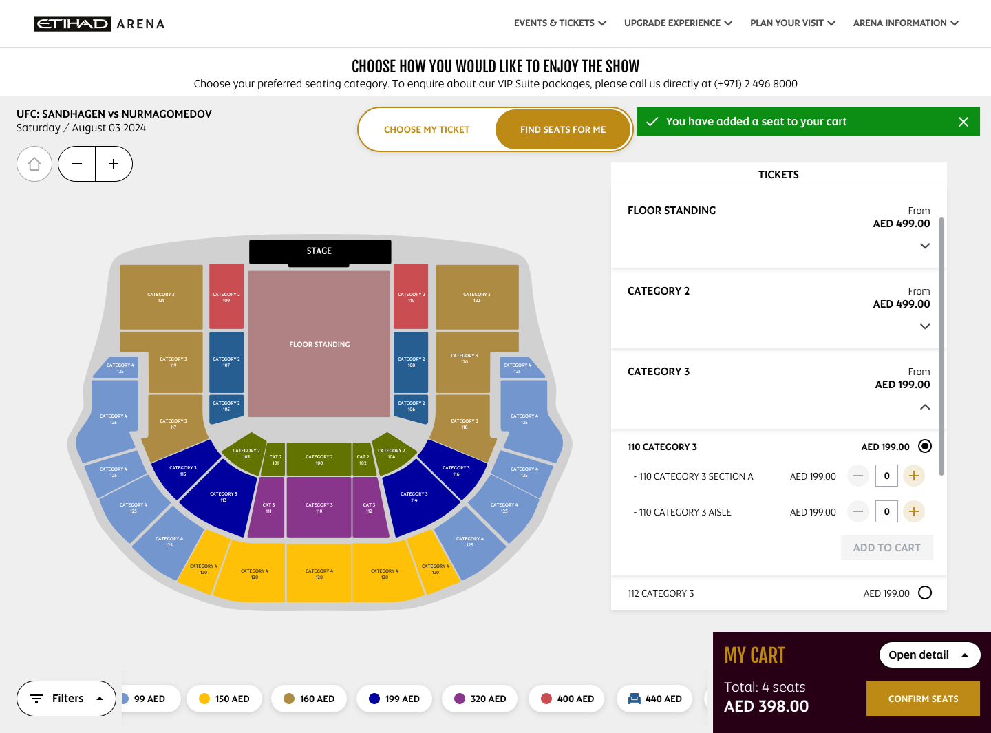
Screenshot 12
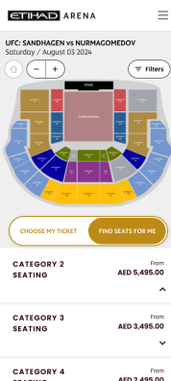

Screenshot 13 (Mobile View)

DELIVERABLE #3 – FLOW MODE PANEL

To switch from Choose my Seats to Find my Seats flow type


Screenshot 14



Screenshot 15
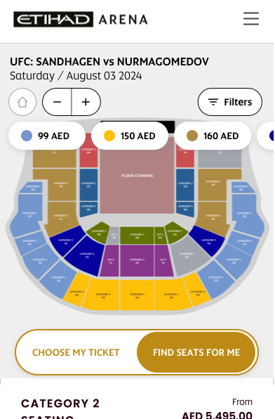

Screenshot 16 (Mobile View)
DELIVERABLE #4 – FILTERS
Implement filter options on the 2D map/seat selection screen to allow users to refine seat selection results.

Define

- i18N to enable/disable the while panel
- i18N to enable/disable each single filter inside

Provide filters for criteria such as price range, seat location, and availability etc.

- Price Range Filter: Allow users to set a minimum and maximum price range to filter seats within their budget.
  - This should be presented as a range slide bar; The minimum should be equal to the minimum price returned by services for the specific performance. Same for the maximum
  - The user can set a range of prices by moving the Minimum pointer of the slider and the maximum also,
  - The list of zones on the podium is then filtered showing only the ones its price is between the range selected by user
  - Consequently, zones on map are activated, based on visible zones on the podium

- Seat Location Filter: Enable users to filter seats based on their location in the arena, such as front row, middle section, Aisle seat, best seat, or near the stage.
  - The filter will pre represented with a sort of select list.
  - User will select one or more items from the above list (e.g. "near the stage" + "front row")
  - We will then filter the list of zones, showing only the ones that have into a specific i18n the selected keyword
  - Consequently, zones on map are activated, based on visible zones on the podium

- Availability Filter: Provide an option to filter categories based on their availability, showing only seats that are currently available for purchase.
  - choosing this option, we can show only zones not sold out
  - Consequently, zones on map are activated, based on visible zones on the podium

- Amenities Filter: Enable users to filter seats based on amenities, such as seats with VIP access, in-seat service, or exclusive lounges.
  - The filter will pre represented with a sort of select list.
  - User will select one or more items from the above list (e.g. "exclusive lounges" + "in-seat service")
  - We will then filter the list of zones, showing only the ones that have into a specific i18n the selected keyword
  - Consequently, zones on map are activated, based on visible zones on the podium

- View Filter: Provide a filter for seat views, allowing users to filter seats based on whether they have a clear view of the stage or other key areas.
  - The filter will pre represented with a sort of select list.
  - User will select one or more items from the above list (e.g. "clear view")
  - We will then filter the list of zones, showing only the ones that have into a specific i18n the selected keyword
  - Consequently, zones on map are activated, based on visible zones on the podium

- Group Size Filter: Allow users to filter seats based on the number of seats available together, suitable for their group size.

- Seat Type Filter: Enable users to filter seats based on their type, such as standard seats, premium seats, or box seats.
  - The filter will pre represented with a sort of select list.
  - User will select one or more items from the above list (e.g. "premium seats")
  - We will then filter the list of zones, showing only the ones that have into a specific i18n the selected keyword
  - Consequently, zones on map are activated, based on visible zones on the podium

These filters will help users quickly narrow down their seat selection based on their preferences and requirements, enhancing the overall user experience on the Etihad Arena website.

Filter Option Design

- Once the user clicks on the Filters Option, the Filters panel is opened to the left side (Refer Screenshot 17).
- User can define filters parameters to refine the search results
- Filters will be applied once the user press on "Apply filters" Button
- The zones that are not matching the request criteria will be hidden on podium list
- The map will show as available only zones matching filters criteria
- User can select Seat Categories and filter on the same as well (Refer Screenshot 18)

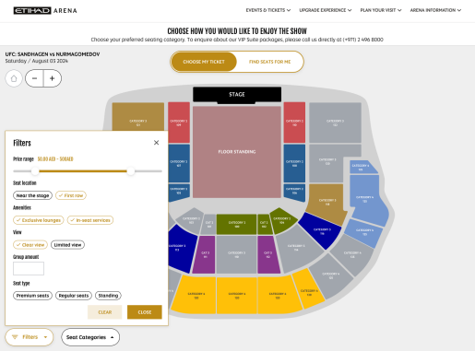
Screenshot 17 (Web View)

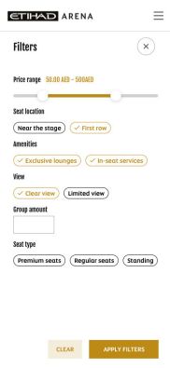
Screenshot 18 (Mobile View)

If filters are applied, the list of criteria’s will be shown in this way (Refer Screenshot 19)
mobile version we will show only the count of filters selected (Refer Screenshot 20)

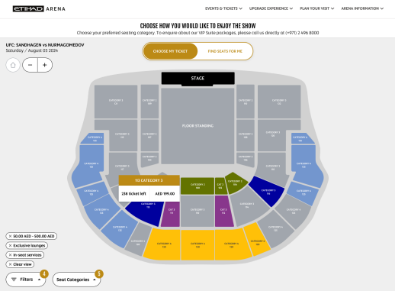
Screenshot 19 (Web View)

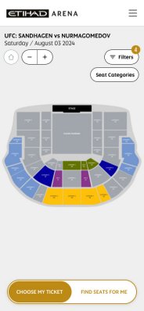
Screenshot 20 (Mobile View)
DELIVERABLE #5 – ZONES GROUPING BY PRICE
Is required the implementation of a filter that, groups zones by price range.
- Clicking on each button, map zones are activated consequently
- User can activate more than one at same time
- The list can be horizontally scrollable
- VIP zones must be marked with a specific icon

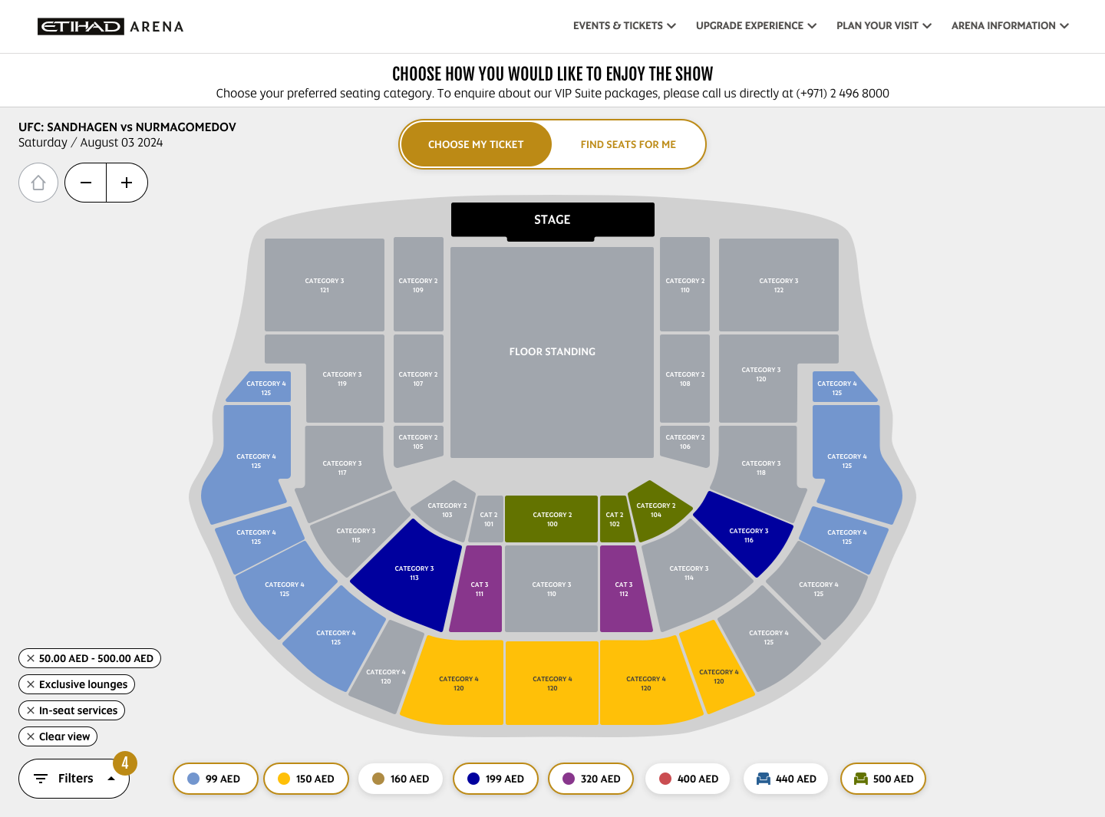

Screenshot 21

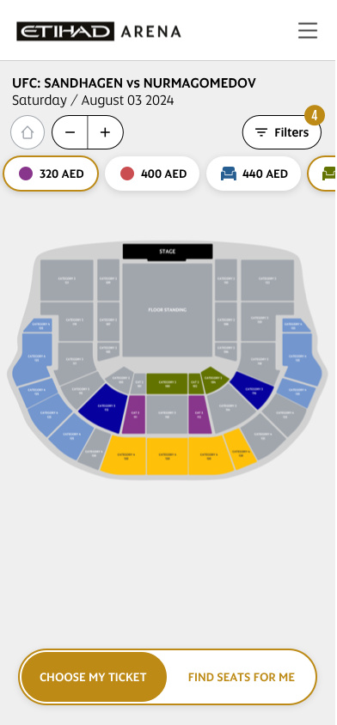

Screenshot 22

DELIVERABLE #6 – ALL OTHER OPTIONS
Below are listed cases to handle related to Map plugin implementation

USE CASES - TOP VIEW

- The map shows all zones of the arena for the selected performance.
- Zones color, comes from BOS configuration. Zones with no availability must be greyed out.
- Hovering on each zone, a popup is shown with:
  - Zone name
  - Total capacity (e.g. 500 available)
  - Product Name + Price

USE CASES - ZONE VIEW - SEATS SELECTION

- The map shows all seats for the selected zone (Phase 1).
- The map will show all seats of all zones highlighting the Selected Zone (Phase 2)
- A mini-map must be shown to let the user understand the selected zone location in the arena
- Seats color comes from BOS configuration. Seats with no availability must be greyed out.
- Legenda
- Isolated seats functionality
- Hovering on each seat, a popup is shown with:
  - Seats details (e.g. Section 104 - Row A - Seat 10 - Price 100 AED)
Additionally, we show also: Low / Normal visibility information and Seat type (POD / VIP etc...)

USE CASES - SEATS SELECTION - LEGEND

On seats selection level, we should show a legend to describe seats represented in the map (Refer Screenshot 23)
- Available seats
- Unavailable Seats
- Reduced visibility seats (if present)
- POD / VIP etc., seats if present

NOTE: on configuration / plugin side, we have a list of enumeration to define those seats, so the list may change based on client's needs



Screenshot 23

USE CASES - SEATS SELECTION - ISOLATED SEATS ERROR

Based on configuration, we can make the "isolated seats" check active or not.
The aim of this control, is to avoid users leave empty single seats.

seat left empty during the selection (Refer Screenshot 24)
textual error that explains the user the problem on the selection he is doing

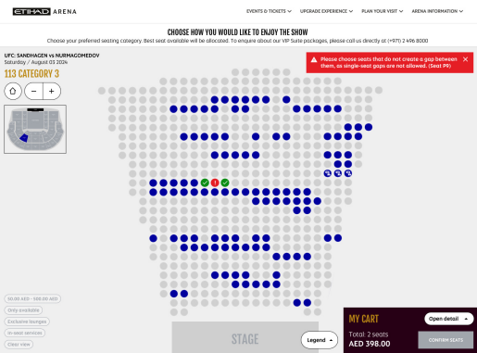

Screenshot 24

